Performance of a High-perveance Electron Gun with a Convex Cathode

A.Shemyakin, G.Kuznetsov, A.Sery, V.Shiltsev, N.Solyak
Fermilab, P.O.Box 500, Batavia, IL 60510, USA

Abstract
Strongly magnetized electron gun with a convex cathode can provide homogenous transverse current distribution in low temperature electron beam with high perveance of 5-10 μA/V^{3/2}. Such a gun was successfully tested with currents up to 10 A at the prototype set-up for beam-beam compensation in the Tevatron collider. In this article we present the test results. Electron guns of this type can be used in electron cooling and beam-beam compensation devices.
- Introduction
On of the most important characteristics of an electron gun is its perveance 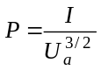, where I is the beam current and U_{a} is the anode potential with respect to the cathode. For guns with flat or concave cathodes, current density inhomogeneity becomes large when the perveance exceeds the value of 1 – 2 μA/V^{3/2}. However, electron beams with higher perveance are needed in number of applications where charge or current density is a key parameter. One example is a set-up for compensation of beam-beam effects in high energy colliders [1] where a high-current electron beam needs to be modulated with high duty factor. Another example is electron cooling at low energies, where an increase of beam current at a fixed energy increases cooling rate (see, for instance, [2]). For these and similar cases, where the gun has to be immersed into a strong longitudinal magnetic field, the perveance can be increased by usage of a convex cathode [3]. Prototype of the gun was tested at the “Tevatron Electron Lens” (TEL) prototype set-up at Fermilab [4]. The paper presents results of the gun tests.
2 Gun description
The mechanical schematic of the gun is shown in Fig.1 and its main parameters are listed in Table 1.
The gun is fabricated at Budker INP (Novosibirsk, Russia) and employs a spherical dispenser cathode made by HeatWave (Watsonville, CA). A control electrode around the cathode (an analog of the Pierce electrode) is insolated from the cathode and is used to control the shape of the current density distribution. The anode shape is optimised for the maximum smoothness of the radial electric field E_{r}.

Table 1: Main parameters of the tested gun
Beam diameter in the gun | 10 | mm
Anode voltage, max | 15 | kV
Beam current, DC, max | 3 | A
Beam current, pulsed, max | 10 | A
Magnetic field on cathode | 0.5- 2 | kG
Control electrode voltage (with respect to the cathode) | 0 - -15 | kV
Gun perveance | 5.86 | μA/V^{3/2}
Figure 1: Mechanical schematic of the test bench. Electron gun and beam analyzer are shown in detail. 1- cathode, 2- control electrode, 3- anode, 4- water-cooled collector bottom with a 1mm hole in the center, 5- diaphragm with 0.2 mm hole, 6- retarding electrode, 7- analyzer collector, 8- gun solenoid, 9- drift tube, 10- main solenoid, 11- collector solenoid.
3 Gun simulation
The gun was simulated and optimised using SSAM code [5] in order to have current density distribution uniform within 10% at gun perveance of 5 μA/V^{3/2}. Another important gun parameter is the value of the electron velocity 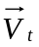 transverse to the magnetic field. It is convenient to split the velocity into two components:
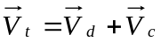 . (1)
Here 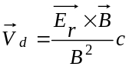, where B is the strength of the longitudinal magnetic field in the gun and c is the speed of light, 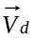 denotes the drift velocity, and 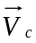 is the cyclotron component which is due to cathode temperature and (mostly) transverse electric field on the cathode [6]. In a space free of external electric fields, modules of both components are constant and 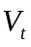 oscillates with the cyclotron frequency eB/mc. Note, that in this case the value of 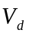is determined by beam parameters only:
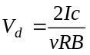, (2)
where I is the beam current, v is average z-component of electron velocity, and R is the beam radius. The drift velocity can not be eliminated in the gun, and it is a natural unit to characterize its performance. If 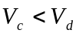, the effective beam transverse velocity does not depend on the gun optics.
Results of the simulation are shown in Fig.2. The value of the cyclotron component is less than drift velocity at B > 1 kG.
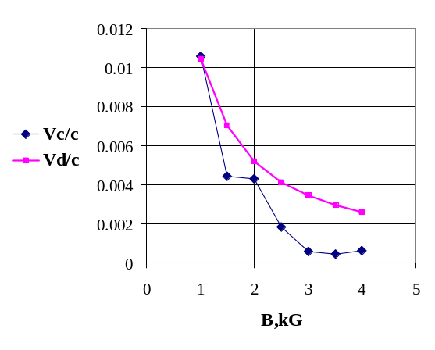Figure2: Results of simulation of the drift and cyclotron components at U_{a}= 10 kV, I= 5A. The curves represent maximum values in the beam in the drift tube.
4 Test bench
Gun characteristics were measured at a test bench (Fig.1) used at Fermilab for prototyping of the TEL elements. The test bench consists of the gun immersed into longitudinal magnetic field B_{gun} of 1- 2 kG generated by a gun solenoid, a drift tube with diagnostics placed inside 4 kG, 2 m long main solenoid, and a collector, also inside a separate solenoid. The collector is equipped by a beam analyzer, similar to ones described elsewhere [7]. A small pin-hole (∅ 0.2 mm) in the collector bottom cuts a narrow flow, which passes through a retarding electrode and is absorbed by an analyzer collector. By use of steering dipole corrector coils in the main solenoid one can scan electron beam across the pin-hole, and the analyzer collector current I_{ac} recorded as a function of the beam transverse position reveals the beam current density distribution.
If the potential of the retarding electrode with respect to the cathode U_{r} is close to zero, then only electrons with a high enough longitudinal momentum 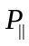 reach the analyzer collector. Derivation of the measured function 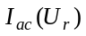 gives an electron distribution over a “longitudinal energy” 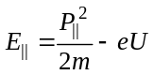, where m and (-e) are electron mass and charge. < should be U_{r} >
5 Results of measurements
Except high perveance, the gun is not much different from a planar cathode gun. The beam current follows the Child’s law with a good precision. The perveance slightly increases at lower magnetic fields (5.9 at 2 kG, 6.2 at 0.5 kG).
For the TEL project it is important to control transverse a current density distribution. The distribution needs to be adjustable preferably from nearly uniform to a bell-like shape[1]. One can do it by regulation of the control electrode voltage U_{ce} (Fig.4). At equal control electrode and cathode potentials (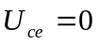), the measured gun perveance of 5.9 is slightly higher than 5.6 found in the simulation . Edge peaks in the current density profile indicate and computer simulations confirm that the reason is some 0.2 mm protrusion of the emitted surface from the control electrode in comparison with its optimum position. The shift occurs because of either uncertainty in the thermal expansion of the cathode or mechanical misalignment. The effect can be easily corrected by applying small negative voltage to the control electrode. With the perveance decreased to its nominal value, the current density variation in the beam is about 10 %. With further increase of the absolute value of U_{ce} , the beam profile approaches to bell shape.
Distribution of the longitudinal energy of electrons is close to the Gaussian one:
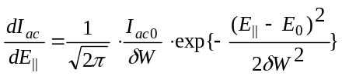, (3)
where I_{ac0} is the maximum value of the analyzer collector current typically measured at the potential of the retarding electrode equal to 100 V with respect to the cathode. The energy dispersion δW and the shift of the spectrum maximum E₀ depend on the beam current (Fig.5) in a good accordance with known formulae describing relaxation in the beam [8]. In all measurements values of E₀ measured in the center and near beam periphery were equal within precision of measurements, which was about 1 V at currents up to 1A. The fact implies that the possible “transverse energy” acquired in the gun is below 1eV.
Described measurements are done in DC regimes. Work with beam currents above 0.5 A needs a decrease of the collector magnetic field to prevent thermal problems at the irradiated surface. In such a regime the beam occupies the collector entrance aperture and can not be shifted for profile measurements. The maximum current in a DC operation is 3 A and is limited by cooling of the collector. The system behaviour at higher currents was investigated in a pulsed regime with the pulse width of 0.2-1 μs. No significant deviation from results of simulations and DC measurements was found up to the maximum achieved current of 10 A.
6 Conclusion
Results of simulations and measurements show that the gun with a convex cathode emits a homogeneous beam with perveance of about 6 μA/V^{3/2}. For generation of a 10 A beam, strength of the longitudinal magnetic field in the gun has to be at least 1 kG. Additional transverse temperature due to of the specific cathode geometry does not exceed 1 eV at the beam current of 0.5 A and field strength of 1 kG.
acknowledgements
Original idea of the gun belongs to A.Sharapa who passed away in 1998. Authors acknowledge participation in gun commissioning of the BINP (Novosibirsk) team, including A.Alexandrov, P.Logatchov, B.Skarbo, A.Sleptsov, and B.Sukhina.

REFERENCES
[1] V.Shiltsev, et.al, Phys.Rev.ST-AP, 2 (1999), 071001.
[2] CERN
[3] A.N.Sharapa et al., NIM- A406 (1998), p.169.
[4] C.Crawford, et.al, Proc. 1999 PAC, p. 237.
[5] D.G. Myakishev, M.A. Tiunov, and V.P. Yakovlev, Int. J. Mod. Phys. A 2B(1993) 915
[6] D.ryutov, BINP 83-146, Novosibirsk (1983)
[7] For example, Kudelainen V.I. et al, , Sov.Phys.JETF, 56 (1982), p.1191; Alexandrov A.V. et al, , Meas. Sci. Technol. 4 (1993), p.764
[8] relaxation

